**RUTLAND HOUSING AUTHORITY REQUEST FOR QUALIFICATIONS FOR LEGAL SERVICES**

**July 7, 2025**

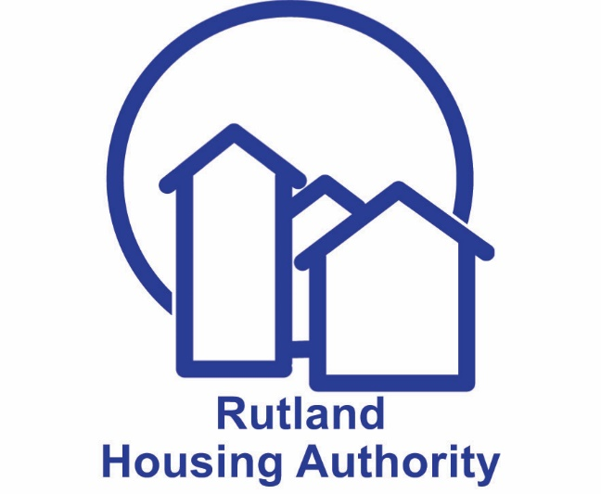

**-**

**RUTLAND HOUSING AUTHORITY**

**REQUEST FOR QUALIFICATIONS FOR LEGAL SERVICES**

The Rutland Housing Authority (RHA) is hereby soliciting sealed proposals for legal services. These legal services will include, but are not limited to, matters dealing with tenant/landlord law including evictions, federal and state public and affordable housing laws, rules, regulations, administrative matters, collective bargaining/employment matters and procedures, advisory opinions and grievance procedures.

These services will be required on an as- needed basis. The RHA will not provide a retainer fee but will reimburse the Attorney for time spent on cases and work assigned at an hourly rate monthly. The attorney will also be reimbursed for approved out-of-pocket expenses related to the services provided.

The RFQ may be obtained online at www.rhavt.org under Opportunities: Procurement or by contacting the RHA at [lphillips@rhavt.org](mailto:lphillips@rhavt.org). One original and three copies of the sealed proposal must be submitted to the RHA at 5 Tremont Street, Rutland, VT 05701, no later than **1:00 p.m. on August 25, 2025.** All proposals received later than said date and timewill not be opened or considered. The RHA reserves the right to reject any or all proposals and to waive any informalities in the proposals and to accept the proposal which it deems to be most favorable to the Authority.

The base contract shall be for a period of three (3) years with an option to renew at the RHA’s discretion for an additional three (3) year period. Any questions or requests concerning this RFQ shall only be directed in writing by email to [lphillips@rhavt.org](mailto:lphillips@rhavt.org). Written responses will be forwarded to all interested parties. No inquiry received within three (3) business days of the date fixed for opening of proposals will be given consideration.

**INTRODUCTION**

The Rutland Housing Authority (RHA) is soliciting sealed proposals for legal counsel on an as-needed basis to provide a wide range of legal services with a primary focus on tenant/landlord matters. These legal services will include, but are not limited to, matters dealing with federal and state public and affordable housing laws, rules, regulations, grievance procedures, administrative matters, and collective bargaining/employment laws and procedures.

The RHA owns and operates 134 Section 8 Project Based housing units (formerly Public Housing), 78 tax credit, affordable rental housing units and administers 291 federal Section 8 Housing Choice Vouchers. It employs 18 staff, 5 of whom are represented by the American Federation of County, State and Municipal Employees Local 1201-010. The current Collective Bargaining Agreement runs through March 31,2028.

___________________________________________________________________________________

1. **SCOPE OF SERVICES**

Legal Counsel will provide a wide range of legal services in connection with RHA’s operations and affordable housing portfolio and rental voucher programs on an as-needed basis**,** which include, but are not limited to the following:

1. As necessary, attend RHA Board of Commissioners meetings to provide legal advice and to be available for consultation with RHA staff and Commissioners acting in their official capacity.
2. Review the legality of all contracts to which the RHA is a party and advise on disputes arising under such contracts.
3. Prepare contracts and other legal documents as required in the course of RHA business.
4. Oversee, guide and assist staff with tenant eviction procedures and legal matters pertaining to tenancy including:
   * + 1. a. Tracking pending actions to ensure timely and accurate court filings.  
          b. Adequately preparing RHA staff for court hearings and testimony.
       2. c. Negotiating favorable settlements with tenant advocates including Vermont Legal Aid
       3. d. Provide prompt and consistent communication with RHA staff.

e. Monitor rents paid in to court for compliance and request release of funds on behalf of the RHA

1. Attend conferences and/or hearings regarding RHA business with the City of Rutland and HUD or its representatives upon invitation, and with other public or private agencies.
2. Advise and assist with the implementation of policies to ensure that they comply with local, state and federal requirements.
3. Serve as liaison with recognized tenant groups or their legal representatives or agents, when directed to do so by the RHA.
4. Respond in a good-faith manner to tenant inquiries of a legal nature.
5. Provide advice regarding and represent the RHA in actions by or against the RHA before a Court, HUD, the Vermont Human Rights Commission, or any other public agency;
6. Render other legal services normally required in the conduct of RHA business.
7. Assist in the enforcement of RHA rules and regulations, if there are any, with letters, calls or other appropriate action.

13. Representation of the RHA in all matters pertaining to labor relations and employment law including negotiating union contracts and union arbitration as requested.

14. Perform legal services in connection with land acquisition for new housing developments or project improvements, including searching titles and preparing deeds, securing exceptions and/or variances from zoning and building ordinances, applying for zoning alternatives, and carrying out eminent domain proceedings where necessary.

___________________________________________________________________________________

1. **SUBMISSION INSTRUCTIONS**

Proposers responding to this RFQ are required to submit by mail or hand delivery one original signed proposal and three (3) copies of their proposal to: CEO, Rutland Housing Authority, 5 Tremont Street, Rutland, VT 05701, no later than 1 p.m. on Monday, August 25, 2025.

Each proposal must be in a sealed envelope marked with the proposer's name, address, and telephone number. **Proposals must be in loose page form (not bound) and not duplex printed.** Proposers are required to submit one original and three copies of its Technical Proposal and Fee Proposal as follows:

* One envelope shall be marked: **“Technical Proposal for Legal Services”**
* The second envelope shall be marked: **“Fee Proposal for Legal Services”**

Any modification or withdrawal shall be made in writing and received by the RHA prior to the time and date that the proposal is due. Proposal modifications must be submitted in a sealed envelope clearly labeled **“Modification # _____ RHA Legal Services”.**

**______________________________________________________________________**

1. **TECHNICAL PROPOSAL SUBMISSION REQUIREMENTS**

The Technical Proposal shall be formatted as listed below:

1. **Letter of Interest**. A cover letter introducing the firm and expressing interest in providingservices to the Authority.
2. **Firm Information.** Provide the date the company was started and the number ofconsecutive years the proposer has been providing legal services. The proposer shall also provide the name and address of all housing authorities, affordable housing organizations and municipalities to which the proposer provides legal services in the State of Vermont and any significant municipal or public housing authority clients located elsewhere.
3. **Service Approach.**
   1. Describe in detail how your firm will service our account and its legal expertise and ability to provide services in the following areas:
      1. Public housing authority or other local, state or federal agency/entity issues.
      2. State and Federal regulations relating to public and affordable housing.
      3. State and/or Federal court appearances.
      4. Tenant/landlord proceedings and experience with advocates such as Vermont Legal Aid.
   2. Describe your firm’s ability to respond to time sensitive matters as requested by the RHA, such as emergency court actions or other emergency legal matters.
   3. Provide the names and resumes of any key personnel that will be working directly with the RHA and their area of expertise.
4. **Licenses.** Please submit your licenses to practice law in the State of Vermont.
5. **Certificate of Insurance.** Submit a current Certificate of Insurance with the coverage identified below:

General Liability $1,000,000

Workers Comp/

Employers’ Liability $1,000,000

Automobile Liability $1,000,000

___________________________________________________________________________________

**IV.** **EVALUTION PROCESS FOR AWARD**

Proposals shall be reviewed by the RHA Procurement Review Committee appointed by the RHA CEO and shall be reviewed by the RHA Procurement Review Committee in four phases.

1. All proposals will be evaluated based on the technical evaluation criteria.
2. The RHA Selection Committee shall rate and compose a short list of Proposers based on the technical evaluation criteria.
3. Fee Proposals will be opened and evaluated.
4. A Proposer may be requested to attend an interview with the RHA and make a

presentation and introduce attorneys who would be assigned to RHA cases.

The proposal, which is most advantageous in serving the interests of the RHA, with price and all evaluation factors considered, including proposed revisions, will be recommended to the CEO for the contract award.

1. **TECHNICAL EVALUATION CRITERIA**
2. **Public and affordable housing experience with state and federal laws, regulations and litigation in state and/or federal courts.**

Demonstrated professional qualifications, education, and training. Must have previous experience in tenant/landlord law and a willingness to learn state and federal public housing and voucher programs, tenant grievances, including litigation in both state and federal courts, and public/affordable housing operations. Must provide references for same. ***(35 points)***

1. **Responding to Rutland Housing Authority needs.**

Demonstrated ability to respond promptly to RHA needs relating to evictions proceedings, emergency court actions or other emergency legal matters and provide a high quality of representation. Must provide references for same. ***(35 points)***

1. **Collective bargaining laws and procedures, labor negotiations, grievance and disciplinary hearings, and all labor/employment issues.**

Demonstrated professional qualifications, education, and training. Must have experience in collective bargaining laws and procedures, labor negotiations, grievance and disciplinary hearings, and all labor/employment issues. Must provide references for same.

1. ***points)***
2. **FEE PROPOSAL**

In a separate sealed package, please include the amount the proposer will charge with an **hourly** **rate** for each category of legal services. This rate shall be fixed throughout the duration of thecontract. The RHA will not provide a retainer fee but will reimburse the Attorney for time spent on cases and work assigned at an hourly rate not to exceed the submitted price proposal. The Attorney will also be reimbursed for approved out-of-pocket expenses related to his/her caseload.

The fee proposal, although secondary to the technical evaluation criteria consideration above, will be utilized in determining the proposal most advantageous to the RHA; however, as technical evaluation points become more equal, price may become the determining factor. While the fee proposal has no numerical weight, it is criterion in the overall evaluation of proposals. The fee proposal must be considered reasonable.

If the RHA is satisfied with the fee proposal of the top-ranked Proposer, it will recommend to the RHA CEO that the contract be awarded to that Proposer. If not satisfied, the RHA will proceed to the next ranked respondent on the list, until a satisfactory agreement is reached. A contract **may** be awarded to a Proposer who does not submit the lowest fee proposal.

___________________________________________________________________________________

1. **OTHER TERMS AND CONDITIONS**
2. **CONTRACT AWARD**

A contract award shall be made to the Proposer whose proposal is most advantageous to the RHA, taking into consideration experience, staff capacity, references and the plan for providing the services, as well as the proposal price. The RHA will award the contract by written notice to the selected Proposer (the "Contractor") no later than forty-five (45) days after the date designated for receipt of proposals; the parties may extend the time for acceptance by mutual agreement.

1. **ACCEPTANCE OF RFQ AND CONTRACT TERMS**

The proposer’s submission of a proposal in response to the RFQ shall constitute acceptance by the Proposer of the terms and conditions of the RFQ. If the Proposer's proposal is accepted for contract award, the Proposer agrees to enter in to a contract with the RHA in a form substantially similar to the contract form appended hereto as Appendix A.

1. **EXPENSE OF RFQ SUBMISSION**

All expenses incurred in the preparation and submission to the RHA of proposals in response to this RFQ shall be borne by the Proposer.

1. **RHA OPTIONS**

The RHA reserves the right to cancel this RFQ, or to reject, in whole or in part, all proposals received in response to this RFQ, upon its determination further reserves the right to waive any minor informalities in any proposals received, if it is in the public interest to do so. The determination of the criteria and process whereby proposals are evaluated, the decision as to who shall receive a contract award, or whether to award, shall be made as a result of the RFQ, shall be at the sole and absolute discretion of the RHA.

A proposal may be corrected, modified, or withdrawn, provided that the correction, modification, or request for withdrawal is made by the Proposer in writing and is received at the place and prior to the date and time designated in the RFQ for receipt of Proposals. After such date and time, the Proposer may **not** change the proposal fee or any other provision of its proposal in a manner prejudicial to the interests of the RHA and/or fair competition.

The RHA shall waive any informalities or allow the Proposer to correct them. If a mistake and the intended fee proposal are evident on the face of the proposal, the RHA shall correct the mistake to reflect the intended correct fee proposal and shall notify the Proposer in writing and the Proposer may not withdraw its proposal. A Proposer may withdraw its proposal if a mistake is evident on the face of the proposal, but the intended fee proposal is not similarly evident.

1. **PAYMENT TERMS**

Proposer will be required to submit invoices monthly. The invoice will include a breakdown of all services provided.

**_______________________________________________________________________________**

**VI SUBMISSION OF FORMS**

The proposer must submit the following forms and documents with proposal submission, or the proposal will be deemed non-responsive and rejected.

1. Technical Proposal; ***(Provided by Proposer in a separate sealed envelope)***
2. Fee Proposal Form ***(Form Provided. Submit in separate sealed envelope)***
3. HUD 5369-C Representations and Certifications of Offerors; ***(Form Provided. Submit*** ***w/Technical Proposal)***
4. Non-Collusive Affidavit: ***(Form Provided. Submit w/Technical Proposal)***
5. Debarment Certification **Form Provided, Submit w/Technical Proposal)**
6. Authorization for Verification of References ***(Form Provided. Submit w/Technical Proposal)***
7. Minority and Women-Owned Business Participation ***(Form Provided. Submit w/Technical Proposal)***

**APPENDIX A**

**Contract for Engagement of Legal Services**

**ATTACHMENTS**

**HUD FORM 5369-B – INSTRUCTIONS TO OFFERORS**

**PROPOSED FEE SCHEDULE**

**HUD FORM 5369-C**

**FORM OF NON-COLLUSIVE AFFIDAVIT**

**DEBARMENT CERTIFICATION**

**AUTHORIZATION FOR VERIFICATION OF REFERENCES**

**MINORITY AND WOMEN-OWNED BUSINESS   
PARTICIPATION COMMITMENT FORM**

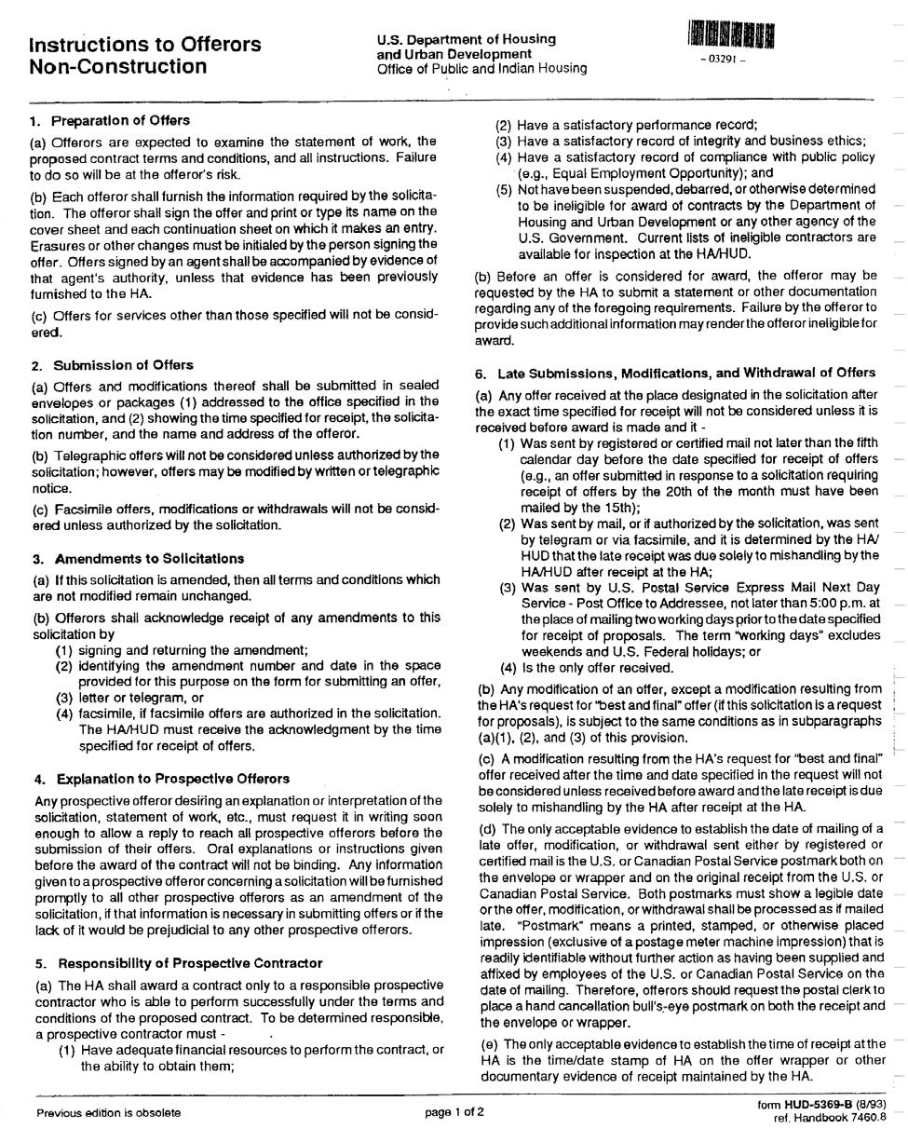

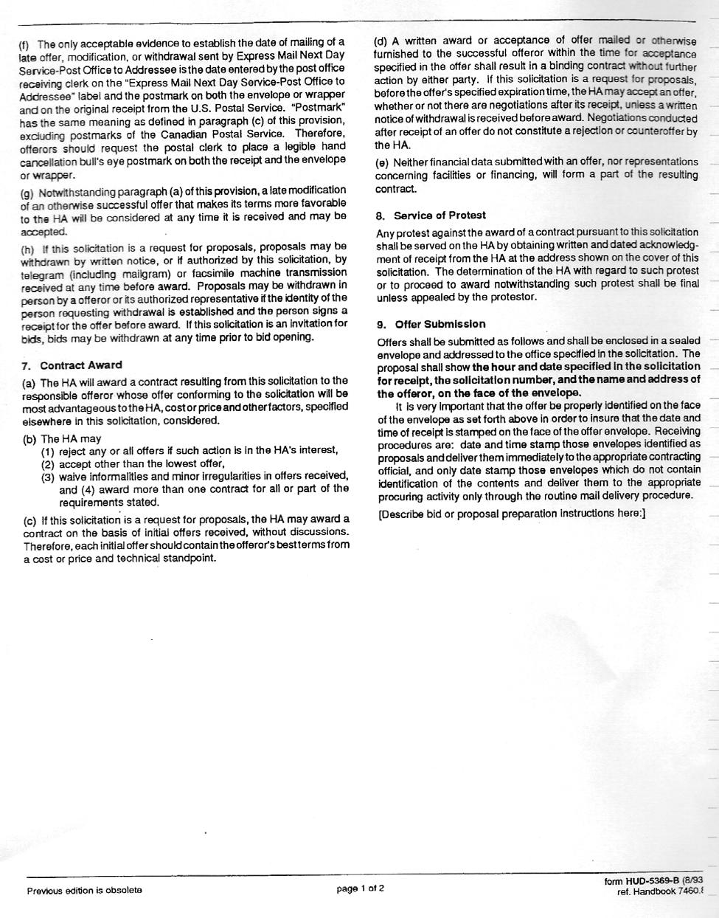

**PROPOSED FEE SCHEDULE**

1. **BASE CONTRACT**

I/We propose to furnish Legal Services on matters dealing with landlord/tenant matters including evictions, federal and state public and affordable housing laws, rules and regulations, administrative matters, advisory opinions, grievances and collective bargaining procedures at the following hourly rates:

|  |  |  |  |  |  |  |
| --- | --- | --- | --- | --- | --- | --- |
| **Hourly rate for services rendered out of Court;** | | | | **$** | **________ ___________** | |
|  |  |  |  |  |  |  |
| **Hourly rate for services rendered in Court;** |  | |  | **$** | **_________** | |
|  |  |  | |  |  |  |
| **Hourly rate for Employment and Labor Relations Matters:** | | | | **$** | **____________________** |  |
| **Hourly rate for collective bargaining:** | |  | |  | **$** |  |

1. **OPTION TO RENEW:** The RHA may exercise its rights to renew this contract for an additionalthree years at the following rates:

**General Services/ Tenant-Landlord Matters (Hourly Rate)**

|  |  |  |  |  |  |  |  |  |  |  |  |
| --- | --- | --- | --- | --- | --- | --- | --- | --- | --- | --- | --- |
|  |  | **Option Year 1** | | | **Option Year 2** | | | | **Option Year 3** | | |
|  | **In Court** | | **Out of Court** | | **In Court** | | **Out of Court** | | **In Court** | **Out of Court** | |
|  | **$** |  | **$** |  | **$** |  | **$** |  | **$** | **$** |  |
|  |  |  |  |  | |  | |  |  |  |  |
|  |  |  | **Employment and Labor Relations** | | | | | | |  |  |
|  |  |  | **Negotiating Union Contracts (Hourly Rate)** | | | | | | |  |  |
|  |  | **Option Year 1** | | | **Option Year 2** | | | | **Option Year 3** | | |
|  | **$** |  |  |  | **$** |  |  |  | **$** |  |  |
|  |  |  |  |  |  |  |  |  |  |  |  |
|  |  |  | **Collective Bargaining (Hourly Rate)** | | | | | | |  |  |
|  |  | **Option Year 1** | | | **Option Year 2** | | | | **Option Year 3** | | |
|  | **$** |  |  |  | **$** |  |  |  | **$** |  |  |
| Date: | | |  |  | Name of Firm: | | | |  | ____ |  |
|  |  |  |  |  | Signature: |  |  |  |  | ____ |  |
|  |  |  |  |  | Title: __________________________________________ | | | | | | |
|  |  |  |  |  | E-Mail Address: _________________________________ | | | | | | |

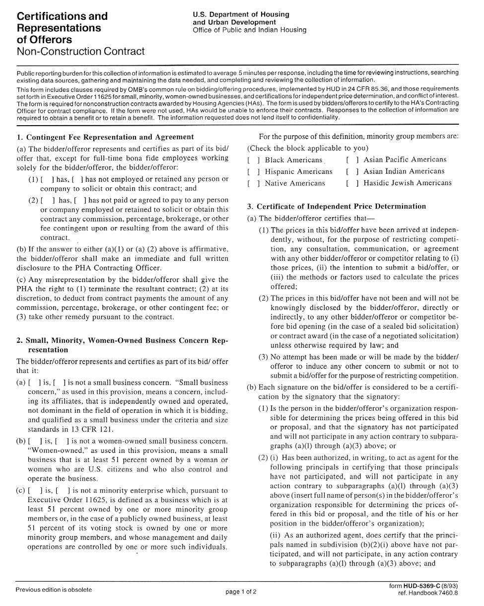

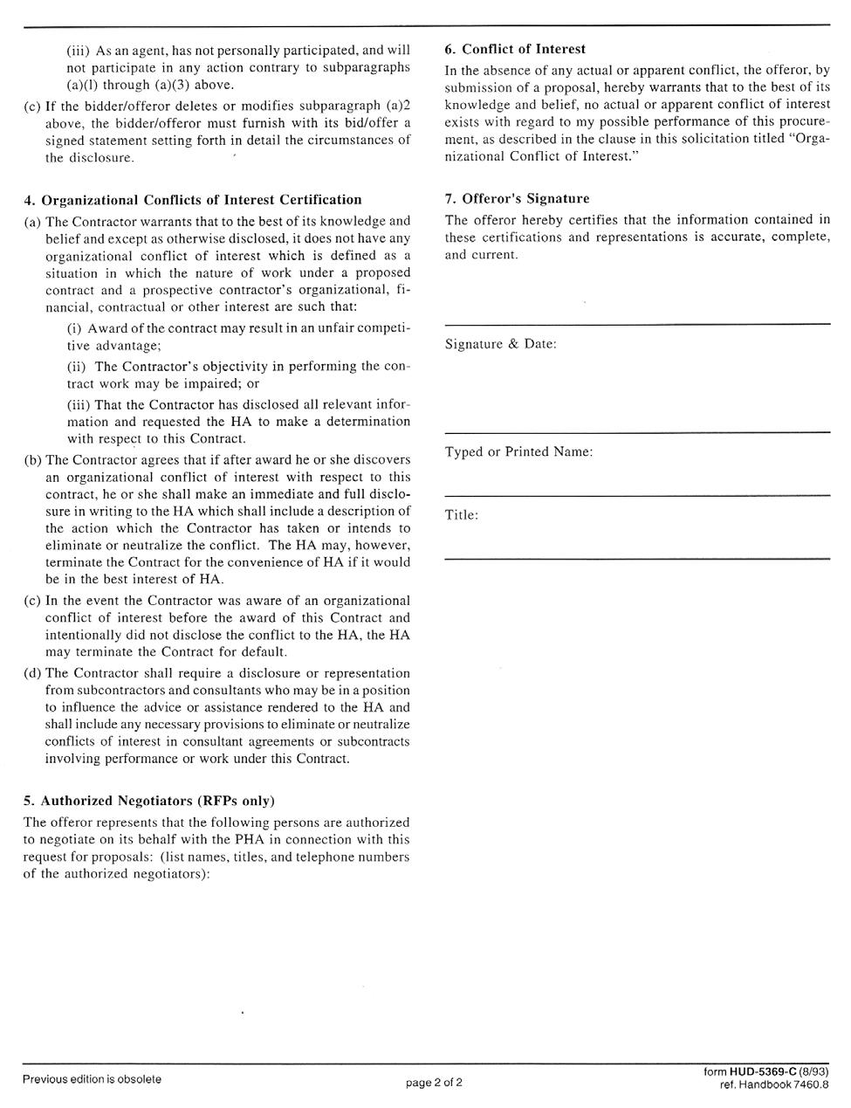

**FORM OF NON-COLLUSIVE AFFIDAVIT**

State of

County of

That he/she is

**(a partner or officer of the firm of, etc.)**

The undersigned certifies under penalties of perjury that this bid or proposal has been made and submitted in good faith and without collusion or fraud with any other person. As used in this certification, the word "person" shall mean any natural person, business, partnership, corporation, union, committee, club or other organization, entity or group of individuals.

Signature of:

**Proposer, if the Proposer is an individual**

**Partner, if the Proposer is a partnership**

**Officer, if the Proposer is a corporation**

**DEBARMENT CERTIFICATION**

The undersigned, a Respondent to the Request for Proposals (RFP) issued by the Rutland Housing Authority, hereby certifies to the Rutland Housing Authority on behalf of itself and each member of Respondents development team, as follows:

In accordance with 24 CFR 85.35, Respondent certifies that neither Respondent, nor any member of the Respondent’s development team is debarred or suspended or is otherwise excluded from or ineligible for participation in Federal Assistance programs under Executive Order 12549 “Debarment and Suspension.”

Date

Respondent (Name of Firm)

By:

Name of Signatory:

Title:

**DRAFT CONTRACT FOR ENGAGMENT OF LEGAL SERVICES**

THIS AGREEMENT MADE AS OF THE ___________ day of ___________________, 2025 by and between   
  
the Rutland Housing Authority and ___________________________________, hereinafter referred to as the “Attorney”

Witnesseth, that the Owner and the Contractor, for the consideration hereinunder named, agree as follows:

**Article 1. Scope of Services.** The Authority hereby retains the Attorney as legal counsel to perform legalservices hereinafter described during the entire term of this agreement in connection with and arising out of the operation and the maintenance of state and federal public housing developments and programs under the jurisdiction of the Authority.

1. As requested, attend RHA Board of Commissioners Meetings to provide legal advice and to be available for consultation with RHA staff and Commissioners acting in their official capacity.
2. Review the legality of all contracts to which the RHA is a party and advise on disputes arising under such contracts.
3. Prepare contracts and other legal documents as required in the course of RHA business.
4. Guide and assist staff with tenant eviction procedures and legal matters pertaining to tenancy.
5. Attend conferences and/or hearings regarding RHA business with the City of Rutland, HUD and the Vermont Human Rights Commission or its representatives upon invitation, and with other public or private agencies.
6. Advise and assist with the implementation of policies to ensure that they comply with state and federal requirements.
7. Serve as liaison with recognized tenant groups or their legal representatives or agents, when directed to do so by the RHA.
8. Respond in a good-faith manner to tenant inquiries of a legal nature.
9. Provide advice regarding and represent the RHA in actions by or against the RHA before a Court, HUD Appeals Body, Vermont Human Rights Commission, or other public agency.
10. Render other legal services normally required in the conduct of RHA business.
11. Supervise and provide guidance to staff on eviction procedures, and where necessary Prosecute evictions; in a timely manner so as to minimize loss of rental income.
12. Assist in the enforcement of RHA rules and regulations, if any, with letters, calls or other appropriate action.
13. Representation of the RHA in all matters pertaining to labor relations and employment law including negotiating union contracts and union arbitration.
14. Perform legal services in connection with land acquisition for new housing developments or project improvements, including searching titles and preparing deeds, securing exceptions and/or variances from zoning and building ordinances, applying for zoning alternatives, and carrying out eminent domain proceedings where necessary.

**Article 2. Term of Contract.** Attorney shall commence its performance of Services under this Contract

for a Base Contract Term of three (3) years from to . The

Authority may, at its sole discretion, exercise its option to renew this contract upon the same terms for an additional period of two (2) additional years by delivering written notice to Attorney at least ten (10) days before expiration of the base contract term.

**Article 3. Contract Sum.** For services listed in Section 1: Scope of Services, above, the Authorityagrees to pay said Attorney at following rates.

|  |  |  |  |  |  |
| --- | --- | --- | --- | --- | --- |
| Hourly rate for services rendered out of Court; | | | $ | ________ ___________ | |
|  |  |  |  |  |  |
| Hourly rate for services rendered in Court; | |  | $ | _________ | |
|  |  | |  |  |  |
| Hourly rate for Collective Bargaining Agreements: | | | $ | ____________________ |  |
| Hourly rate for Labor Relation Arbitration: | | | $ | ____________________ |  |
|  |  |  |  |  |  |

**3.1 Allowable Additional Costs Defined.** Attorneys shall be reimbursed for all necessary travel and

subsistence expenses in connection with the performance of the duties of the Attorney. The Authority shall also reimburse the Attorney for expenses and disbursements incurred in connection with legal matters handled by the Attorney, such as court cost, filing fees, witness fees or other relevant documents. No reimbursement will be due or payable by the Authority until documentation of such expenses has been submitted to and approved by the Authority.

**3.2 Content of Invoices.** Such invoices shall contain an itemized statement for each legal matterassigned of each task completed, the time spent on each such task, the name of the individual who performed such task, the hourly rate or portion thereof charged for such task, invoices, receipts, or other equivalent back-up and the total charge to date for each legal matter assigned. Where work on an assigned legal matter has been completed, the invoice shall reflect that it is the final charge.

**Article 4. Suspension and Termination.** The Authority may terminate services upon ten (10) days’written notice to Attorney for any reason deemed by the Authority to be in the public interest. In the event of termination by the Authority prior to completion of services, Attorney shall be entitled to payment of services performed prior to the effective date of such termination. In the event of termination, payment shall be conditioned upon the delivery to the Authority by the Attorney all opinions, documents and other materials prepared by the Attorney in the performance of services.

**Article 5. Conflict of Interest.** The Contractor covenants, that (1) presently, there is no financial interestand shall not acquire any such interest, direct or indirect, which would conflict in any manner or degree with the performance of services required to be performed under this Agreement; (2) in the performance of this Contract, no person having any such interest shall be employed by the Contractor; and (3) no partner or employee of the firm is related by blood or marriage to any Board Member or employee of the Rutland Housing Authority.

**Article 6. Equal Opportunity.** The Contractor shall not discriminate in employment against any personon the basis of race, color, religion, national origin, sex, sexual orientation, age, ancestry, disability, marital status, veteran status, membership in the armed forces, presence of children, or political beliefs. The Contractor to use best efforts to employ qualified tenants of the Rutland Housing Authority for any positions which are open at the time the contract is awarded or which become open during the term of the contract.

**Article 7. The Contract Documents.** The following, together with this Agreement form the Contract andall are as fully a part of the Contract as if attached to this Agreement or repeated herein: Request for Proposals, Proposer’s Technical and Fee Proposal, and any amendments or addenda issued prior to award and any modification agreed to after the award. No contract amendments shall be made except in writing upon the express agreement of the parties.

**Article 8. Ownership of Documents**. All opinions, documents and other materials prepared by Attorneyin the performance of services hereunder shall be the property of the Authority. The Authority may use any and all such materials for such purposes and so often as the Authority desires, either in whole or in part, or in modified form, without further employment of the Attorney, or additional compensation, therefore. The Attorney shall take no action in derogation of the rights of the Authority to ownership of such property and shall take reasonable actions necessary to protect such rights

**Article 9. State of Vermont Certification.** The individual signing this Contract onbehalf of the Contractor, hereby certifies, under the penalties of perjury, that to the best of their knowledge and belief the Contractor has complied with all laws of the State of Vermont relating to taxes, reporting of employees and contractors, and withholding and remitting child support.

**Article 10. Certification of non-collusion.** The undersigned certifies under penalties of perjury that theirprice quote has been made in and submitted in good faith and without collusion or fraud with any other person. The undersigned further certifies that it is not debarred from doing public work in the State of Vermont or by federal government under any applicable debarment provisions. As used in this certification the word "person" shall mean natural person, joint venture, partnership, corporation, or other business or legal entity.

**Article 11. Worker Documentation Certification.** In accordance with Executive Order 481 theundersigned further certifies under the penalties of perjury that the Contractor shall not knowingly use undocumented workers in connection with the performance of this contract; that pursuant to federal requirements, the Contractor shall verify the immigration status of all workers assigned to such contract without engaging in unlawful discrimination; and that it shall not knowingly or recklessly alter, falsify, or accept altered or falsified documents from any such worker(s). The Contractor understands and agrees that breach of any of these terms during the contract period may be regarded as a material breach, subjecting the Contractor to sanctions, including but not limited to monetary penalties, withholding of payments, contract suspension or termination.

**Article 12. Governing Law.** This Agreement shall be governed by the laws of the State of Vermont.

**Article 13. HUD Contract Clauses.** HUD 7460 8c 05 Table 5-1 Required Contract Clauses for SmallPurchases is applicable to this contract and is attached hereto.

**IN WITNESS WHEREOF,** the Authority and the Attorney have executed this Agreement on the day and date firstabove written.

|  |  |  |  |  |  |  |  |  |
| --- | --- | --- | --- | --- | --- | --- | --- | --- |
| **Attorney** | | |  |  | **Rutland Housing Authority** | | | |
|  |  |  |  |  | **5 Tremont Street, Rutland, VT 05701** | | | |
| Signature: | |  |  |  | Signature: | |  | |
| Title: | | |  | _______Title: CEO | | | | |
|  |  | | |  |  |  | |  |
| Date: __________________________________ | | | |  | Date: __________________________________ | | | |

**HUD ADDENDUM**

**CONTRACT FOR PROFESSIONAL OR TECHNICAL SERVICES**

**PART II – TERMS AND CONDITIONS**

1. Changes. The local Public Agency, from time to time, request changes in the scope of the services to be performed hereunder. Such changes, including any increase or decrease in the amount of the Contractor's compensation, which are mutually agreed upon by and between the Local Public Agency and the Contractor, shall be incorporated in written amendments to this Contract.
2. Personnel
   1. The Contractor represents that he/she has, or will secure at his/her own expense, all personnel required in performing the services under this contract. Such personnel shall not be employees of or have any contractual relationships with the Local Public Agency.
   2. All the services required hereunder will be performed by the Contractor or under his/her supervision and all personnel engaged in the work shall be fully qualified and shall be authorized or permitted under State and local law to perform such services.
   3. No person who is serving sentence in a penal or correctional institution shall be employed on work under this Contract.
3. Anti-Kickback Rules. If applicable, salaries of architects, draftsmen, technical engineers, and technicians performing work under this Contract shall be paid unconditionally and not less often than once a month without deduction or rebate on any account except only such payroll deductions as are mandatory by law or permitted by the applicable regulations issues by the Secretary of Labor pursuant to the "Anti-Kickback Act" of June 13, 1934 (48 Stat. 948; 62 Stat. 740; 63 Stat. 108; title 18 U.S.C., section 874; and title 40 U.S.C., section 276c). The Contractor shall comply with all applicable "Anti-Kickback" regulations and shall insert appropriate provisions in all subcontracts covering work under this Contract to insure compliance by subcontractors with such regulations and shall be responsible for the submission of affidavits required of subcontractors hereunder except as the Secretary of labor may specifically provide for variations of or exemptions from the requirements thereof. (Applies to all contracts for construction or repair.)
4. Withholding of Salaries. If, in the performance of this Contract, there is any underpayment of salaries by the Contractor or by any subcontractor hereunder, the Local Public Agency shall withhold from the Contractor out of payments due to him an amount sufficient to pay to employees underpaid the difference between salaries required hereby to be paid and the salaries actually paid such employees for the total number of hours worked. The amounts withheld shall be disbursed by the local Public Agency for and on account of the Contractor or subcontractor to the respective employees to whom they are due.
5. Claims and Disputes Pertaining to Salary Rates. Claims and disputes pertaining to salary rates or to classifications of architects, draftsmen, technical engineers, and technicians performing work under this Contract shall be promptly reported in writing by the Contractor to the local Public Agency for the latter's decision which shall be final with respect thereto.
6. Equal Employment Opportunity. During the performance of this Contract, the Contractor agrees as follows:
   1. The Contractor will not discriminate against any employee or applicant for employment because of age, race, creed, color, religion, national origin, ancestry, sex, or handicap. The Contractor will take affirmative action to ensure that applicants are employed, and that employees are treated during employment, without regard to their age, race, creed, color, religion or national origin, ancestry, sex, or handicap. Such actions shall include, but not limited to, the following: employment, upgrading, demotion, or transfer; recruitment or recruitment advertising, layoff or termination; rates of pay or other forms of compensation; and selection for training, including apprenticeship. The Contractor agrees to post in conspicuous places, available to employees and applicants for employment, notices to be provided by the local Public Agency setting forth the provisions of this nondiscrimination clause.
   2. The Contractor will, in all solicitations or advertisements for employees placed by or on behalf of the Contractor; state that all qualified applicants will receive consideration for employment without regard to age, race, creed, color, religion, national origin, ancestry, sex, or handicap.
   3. The Contractor will cause the foregoing provisions to be inserted in all subcontracts for any work covered by this Contract so that such provisions will be binding upon each subcontractor, provided that the foregoing provisions shall not apply to contracts or subcontracts for standard commercial supplies of raw materials.
7. Discrimination Because of Certain Labor Matters. No person employed on the work covered by this Contract shall be discharged or in any way discriminated against because he has filed any complaint or instituted or caused to be instituted any proceeding or has testified or is about to testify in any proceeding under or relating to the labor standards applicable hereunder to his/her employer.
8. Compliance with Local Laws. The Contractor shall comply with all applicable laws, ordinances, and codes of the State and local governments, and shall commit no trespass on any public or private property in performing any of the work embraced by this Contract.
9. Subcontracting. None of the services covered by this Contract shall be subcontracted. The Contractor shall be as fully responsible to the local Public Agency for the acts and omissions of his/her subcontractors, and of people either directly or indirectly employed by them, as he/she is of the acts and omissions of person directly employed by him/her.
10. Assignability. The Contractor shall not assign any interest in this Contract, and shall not transfer any interest in the same (whether by assignment or novation) without the prior written approval of the local Public Agency; provided however, that claims for money due or to become due the Contractor from the Local Public Agency under this Contract may be assigned to a bank, trust company, or other financial institution, or to a Trustee in Bankruptcy, without such approval. Notice of any such assignment or transfer shall be furnished promptly to the Local Public Agency.
11. Interest of Members of Local Public Agency. No member of the governing body of the Local Public Agency, and no other officer, employee, or agent of the Local Public Agency who exercises any functions or responsibilities in connection with carrying out of the Project or other work or services to which this Contract pertains, during his/her tenure or for one year thereafter, shall have any interest, direct or indirect, in this Contract or its proceeds.
12. Interest of Other Public Officials. No member of the governing body of the locality in which the Local Public Agency is situated, and no other public official of such locality, who exercises any functions or responsibilities in the review or approval of the carrying out of the Project or other work of service to which this Contract pertains, shall have any personal interest, direct or indirect, in this Contract.
13. Interest or Certain Federal Officials. No member of or Delegate to the Congress of the United States, and no Resident Commissioner, shall be admitted to any share or part of this Contract or to any benefit to arise therefrom.
14. Interest in Contract. The Contractor covenants that he/she presently has no interest and shall not acquire any interest, direct or indirect, in the property to which this Contract pertains or any parcels therein or any other interest which would conflict in any manner or degree with the performance of his/her services hereunder. The Contractor further covenants that in the performance of this Contract no person having any such interest shall be employed.
15. Findings Confidential. All of the reports, information, studies, submissions and/or data prepared or assembled by the Contractor under this Contract are confidential and the Contractor agrees that they shall not be made available to any individual or organization without prior written approval of the Local Public Agency.
16. Commission Fees. The Contractor covenants that he/she has not employed or retained any company or person (other than a full-time bona fide employee working for the Contractor) to solicit or secure this Contract, and that he/she has not paid or agreed to pay any company or person (other than such an employee) any gift, contribution, fee commission, percentage, or brokerage fee, contingent upon or resulting from the award of this Contract.
17. State Requirement. The individual signing this Contract on behalf of the Contractor, hereby certifies under the penalties of perjury that to the best of his/her knowledge and belief the Contractor has complied with any and all applicable laws of the State of Vermont relating to taxes, reporting of employees and contractors and withholding and remitting of child support.
18. Debarment and Suspension (E.O.s 12549 and 12689) - No contract shall be made to parties listed on the General Services Administration's List of Parties Excluded from Federal Procurement or Non-procurement Programs in accordance with E.O.s 12549 and 12689, "Debarment and Suspension." This list contains the names of parties debarred, suspended, or otherwise excluded by agencies, and contractors declared ineligible under statutory or regulatory authority other than E.O. 12549. Contractors with awards that exceed the small purchase threshold shall provide the required certification regarding its exclusion status and that of their principal employees.
19. Clean Air Act (42 USC 7401 et seq.) and the Federal Water Pollution Control Act (33USC 1251 et seq.) as amended - Contracts and subgrants of amounts in excess of $100,000 shall contain a provision that requires the recipient to agree to comply with all applicable standards, orders or regulations issued pursuant to the Clean Air Act (42 use 1251 et seq.). Violations shall be reported to the Federal awarding agency and the Regional Office of the Environmental Protection Agency (EPA).
20. Byrd Anti-Lobbying Amendment (31 USC 1352) - Contractors who apply or bid for an award of $100,000 or more shall file the required certification. Each tier certifies to the tier above that it will not and has not used Federal appropriated funds to pay any person or organization for

Influencing or attempting to influence an officer or employee of any agency, a member of Congress, officer or employee of Congress, or an employee of a member of Congress in connection with obtaining any Federal Contract, grant or any other award covered by 31 USC 1352. Each tier shall also disclose any lobbying with non-Federal funds that takes place in connection with obtaining any Federal award. Such disclosures are forwarded from tier to tier up to the recipient.

1. Accessibility Notice: Section 504 Rehabilitation Act of 1973; the Americans with Disabilities Act

of 1990: the Architectural Barriers Act of 1968 and the Fair Housing Act of 1988, PIH 2002-01 (HA) (the "Accessibility Notice") - The Accessibility Notice provides Federal Funds recipients with information concerning the various non-discrimination and accessibility related laws and regulations they are required to comply with. The Accessibility Notice, as it may be amended, is incorporated by reference into this Contract; a copy of the Accessibility Notice will be provided to the Contractor by the Authority upon request.

Date

Respondent (Name of Firm)

Signature:

______________________________________________

Title:

**RUTLAND HOUSING AUTHORITY**

**AUTHORIZATION FOR QUALIFICATIONS OF REFERENCES**

The undersigned Offeror has submitted a proposal to the Rutland Housing Authority (RHA) in response to the Request for Qualifications (RFQ). The undersigned hereby authorizes and requests all people, firms, corporations, and/or government entities to furnish any information requested by RHA in verification of the reference provided, for determination of the quality and timeliness of the services provided by the Offeror, and all other legal purposes. A copy of this document, after execution by the Offeror, presented by RHA to any such person, firm, corporation and/or government entity shall be as valid as the original.

______________________________________________________________________________

Printed Name and Address of Offeror

______________________________________________________________________________

Printed Name and Title of Authorized Representative or Official of Offeror

______________________________________________________________________________

Signature of Authorized Representative or Official of Offeror Date

**RUTLAND HOUSING AUTHORITY**

**MINORITY AND WOMEN-OWNED BUSINESS PARTICIPATION**

**COMMITMENT FORM**

It is the policy of the Rutland Housing Authority (RHA) to ensure that Minority Businesses Enterprises (MBEs) and Women-owned Businesses (WBEs) are provided the maximum opportunity to participate in all contracts administered by RHA. This requirement applied to all businesses performing as the prime contractor.

For the purpose of this commitment, a MBE is defined as “any legal entity other than a joint venture, organized to engage in commercial transactions, that is at least fifty-one (51) percent owned and controlled by one or more minority group members, or in the case of a publicly owned business, at least fifty-one (51) percent of the stock if minority owned and controlled by minority group members. For the purposed of this commitment, “minority group members” are defined as citizens of the United States who are members of a socially or economically disadvantaged minority group, which includes African Americans, Asian Americans, Native Americans and Pacific Islanders.

For this commitment, a WBE is defined as a “business that is at least fifty-one (51) percent owned by a woman or women, who are U.S. citizens and who control or operate the business.”

RHA has not established a minimum threshold for participation of MBEs and WBEs; however, RHA strongly encourages and affirmatively promotes the use of MEBs and WBEs in all RHA contracts.

Please indicate the percentage of minority business participation in this project. This refers to the percentage of the total dollar value of the contract that will be subcontracted to minority firms. If a minority firm indicate 100 percent.

___________________percent*

Please indicate the percentage of women-owned business participation in this project. This refers to the percentage of the total dollar value of the contract that will be subcontracted to women-owned firms. If a women-owned firm, indicate 100 percent.

___________________percent*

*RHA will consider minority and women-owned participation in awarding this contract. And as on all RHA projects, RHA reserves the right to approve or disapprove any subcontractor list.

To be considered a “minority business”, the business must be so certified.